BILAL RIAZ
BILAL RIAZ

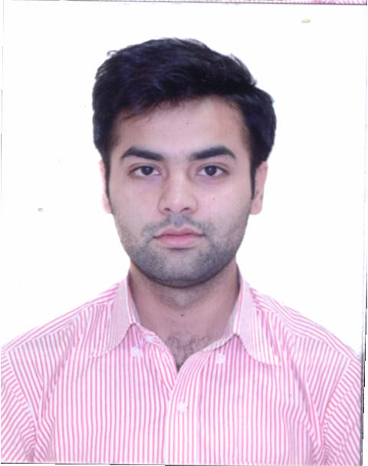
Date of Birth 7-April-1991
Nationality Pakistani
Email briaz418@gmail.com
Cell # 0097150-7235945
Visa Status Employment
Passport# DE9916421

OBJECTIVE
Want to learn new things and use my skills in an efficient and creative manners in Computer Systems & Networks. Have the ability to work in a challenging and multitasking environment & provide the best of my skills professionally to every task assigned, strongly believe in teamwork.

EXPERIENCE
Grand Optics LLC
Working in Head Office as IT Coordinator FEB-2015 to Present
- Worked on LOGMEIN application, Management and maintenance of computers and users remotely.
- Installation of Windows Server and configuration of different Windows server roles.
- Working on Active Directory, Group Policies and management of users.
- Management, Creation and resolve issues of company Emails. Coordination with Etisalat and Du for company internet and Telephone connection.
- Configuration of OUTLOOK against their email and change the behavior of outlook as per user requirement.
- Resolving software’s, printer, scanner and POS issues remotely.
- Resolve Head Office windows problems and risk areas and maintain all network.
- Knowledge of implementing and troubleshooting Cisco Routers & Switches, such as VLAN, Routing ACL etc.
- Knowledge of Microsoft Exchange Server 2010, Installation, Configuration, creation and management of users.
- Knowledge of SQL Server 2008 R2, Installation, configuration and management of database.

Interactive Group of Company SEP-2012 to NOV-2014
Worked in NOC as Assistant Engineer
- Installation of Windows Server and configuration in Data Center environment.
- Worked on Windows Server 2008R2, Active Directory, GPO and management of users.
- Worked on Print Servers, Antivirus Server, DHCP Server and Share Drives.
- Worked as a key source for issue resolving on ticketing application OTRS.s
- Daily or schedule Windows Backup and Recover if require.
- Worked on Wireless Controllers.
- Maintain network reports & documentation.
- Participate in 24x7 on-calls and resolve problems.
CERTIFICATION
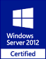
Installation and Configuration of Windows Server 2012 R2

- Installation and Configuration Server and their Roles
- Virtual Machines
- Active Directory
- DNS
- File and Share Access
- Print and Document Services
- Group Policy
- DHCP

EDUCATION
PMAS-UAAR UIIT Rawalpindi, Pakistan 2008-2012
BSCS (Bachelor of Computer Sciences)
BISE Rawalpindi, Pakistan 2006-2008
ICS (Intermediate of Computer Sciences)
BISE Rawalpindi, Pakistan 2004-2006
Matriculation (Science Subjects)
TRAINNING
Corvit Institute of IT, Islamabad, Pakistan
- Microsoft Certified Solution Expert (MCSE 2012)
- Microsoft Certified IT Professional (MCITP)
- Microsoft Exchange Server 2010
NUST Institute of IT Islamabad, Pakistan
• Cisco Certified NET Academy (CCNA)
SKILLS
- Operating System
- Windows Server 2008 & 2012
- Group Policy
- DNS
- IIS
- DHCP
- WDS
- Configure ADC
- Schedule &Daily Backup
- Windows 8
- Windows 7
- Cisco Router and Switches
- Configuration &Troubleshooting
- VLAN
- IP Routes
- Static & Dynamic Routing
- NAT
- ACLs
- SQL Server 2008 R2
- VMware Workstation9.0.2
- Outlook
- Apple Mac.
ACHIVEMENT
Employee of the Month (November, 2013) from Interactive Group of Company
Certificate of Facilitation (September, 2014) from Pakistan Girls Guide Association
OTHER SKILLS
- Marketing
- Fundamental of Management
- Human Recourse Management
COMMUNICATION SKILLS
- Good Communication, Business Writings and Organizational skills
- Languages
- English, Urdu & Punjabi
REFERNCE
References will be furnished upon request.

